**STRENGTHENED THROUGH SUFFERING  
ACTS 25 (ESV)**

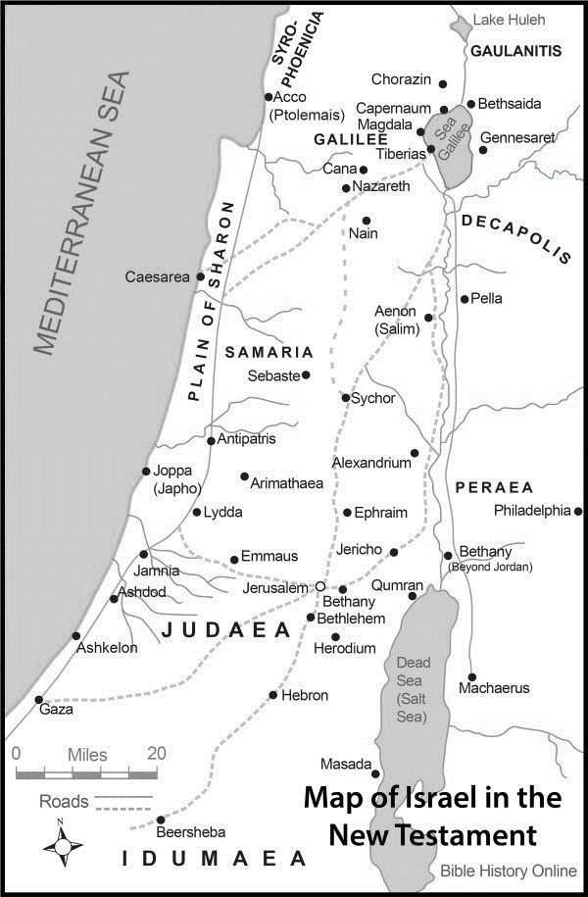**THE SUFFERINGS OF PAUL**

1. **DELAYED HOPE**

**ACTS 24:27 (ESV)***When two years had elapsed, Felix was succeeded by Porcius Festus. And desiring to do the Jews a favor, Felix left Paul in prison.*

**PROVERBS 13:12 (ESV)** *Hope deferred makes the heart sick, but a dream fulfilled is a tree of life.*

NOTES: ***______________________________  
__________________________________  
__________________________________  
__________________________________***

1. **FALSE ACCUSATION**

**ACTS 25:1-7 (ESV)** *Now three days after Festus had arrived in the province, he went up to Jerusalem from Caesarea. 2 And the chief priests and the principal men of the Jews laid out their case against Paul, and they urged him, 3 asking as a favor against Paul that he summon him to Jerusalem—because they were planning an ambush to kill him on the way. 4 Festus replied that Paul was being kept at Caesarea and that he himself intended to go there shortly. 5 “So,” said he, “let the men of authority among you go down with me, and if there is anything wrong about the man, let them bring charges against him.”*

*6 After he stayed among them not more than eight or ten days, he went down to Caesarea. And the next day he took his seat on the tribunal and ordered Paul to be brought. 7 When he had arrived, the Jews who had come down from Jerusalem stood around him, bringing many and serious charges against him that they could not prove.*

NOTES:***__________________________________________________________________________________________________________________________________ ___________________________________________________________________***

1. **SELFISH MANIPULATION**

**ACTS 25:8-12 (ESV)** *8 Paul argued in his defense, “Neither against the law of the Jews, nor against the temple, nor against Caesar have I committed any offense.” 9 But Festus, wishing to do the Jews a favor, said to Paul, “Do you wish to go up to Jerusalem and there be tried on these charges before me?” 10 But Paul said, “I am standing before Caesar's tribunal, where I ought to be tried. To the Jews I have done no wrong, as you yourself know very well. 11 If then I am a wrongdoer and have committed anything for which I deserve to die, I do not seek to escape death. But if there is nothing to their charges against me, no one can give me up to them. I appeal to Caesar.”*

*12 Then Festus, when he had conferred with his council, answered, “To Caesar you have appealed; to Caesar you shall go.”*

NOTES:***__________________________________________________________________________________________________________________________________ ___________________________________________________________________***

1. **UNCERTAIN DIRECTION**

**ACTS 25: 13-22 (ESV) *13****Now when some days had passed, Agrippa the king and Bernice arrived at Caesarea and greeted Festus.****14****And as they stayed there many days, Festus laid Paul's case before the king, saying, “There is a man left prisoner by Felix,****15****and when I was at Jerusalem, the chief priests and the elders of the Jews laid out their case against him, asking for a sentence of condemnation against him.****16****I answered them that it was not the custom of the Romans to give up anyone before the accused met the accusers face to face and had opportunity to make his defense concerning the charge laid against him.****17****So when they came together here, I made no delay, but on the next day took my seat on the tribunal and ordered the man to be brought.*

***18****When the accusers stood up, they brought no charge in his case of such evils as I supposed.****19****Rather they had certain points of dispute with him about their own religion and about a certain Jesus, who was dead, but whom Paul asserted to be alive.****20****Being at a loss how to investigate these questions, I asked whether he wanted to go to Jerusalem and be tried there regarding them.****21****But when Paul had appealed to be kept in custody for the decision of the emperor, I ordered him to be held until I could send him to Caesar.”****22****Then Agrippa said to Festus, “I would like to hear the man myself.” “Tomorrow,” said he, “you will hear him.”*

**THE STRENGTH PROVIDED (THE WHY):**

**JOHN 15:1-5 (ESV)** *“I am the true vine, and my Father is the vinedresser.****2****Every branch in me that does not bear fruit he takes away, and every branch that does bear fruit He prunes, that it may bear more fruit.****3****Already you are clean because of the word that I have spoken to you.****4****Abide in me, and I in you. As the branch cannot bear fruit by itself, unless it abides in the vine, neither can you, unless you abide in me.****5****I am the vine; you are the branches. Whoever abides in me and I in him, he it is that bears much fruit, for apart from me you can do nothing.*

NOTES:***__________________________________________________________________________________________________________________________________ ______________________________________________________________________________________________________________________________________***