COURAGE TO STAND
ACTS 21-22 (ESV)
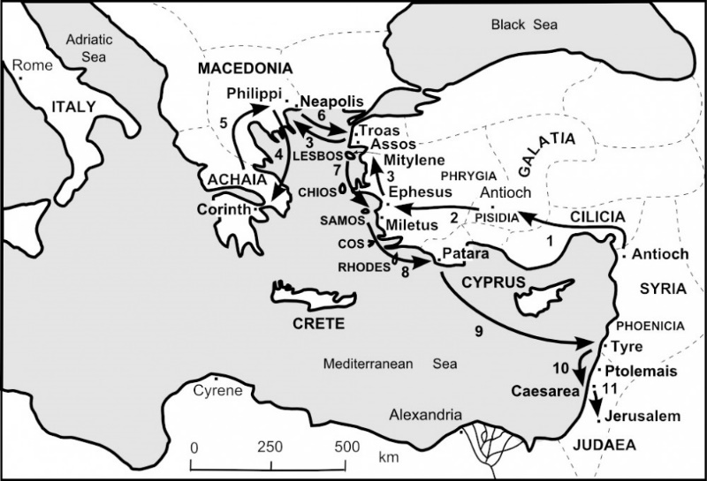
THE SUFFERINGS OF PAUL (ACTS 21-28)
^{21:12} When we heard this, we and the people there urged him not to go up to Jerusalem. ¹³ Then Paul answered, “What are you doing, weeping and breaking my heart? For I am ready not only to be imprisoned but even to die in Jerusalem for the name of the Lord Jesus.” ¹⁴ And since he would not be persuaded, we ceased and said, “Let the will of the Lord be done.”
- A MOB TO DREAD
ACTS 21:27-36 (ESV) ²⁷ When the seven days were almost completed, the Jews from Asia, seeing him in the temple, stirred up the whole crowd and laid hands on him, ²⁸ crying out, “Men of Israel, help! This is the man who is teaching everyone everywhere against the people and the law and this place. Moreover, he even brought Greeks into the temple and has defiled this holy place.” ²⁹ For they had previously seen Trophimus the Ephesian with him in the city, and they supposed that Paul had brought him into the temple. ³⁰ Then all the city was stirred up, and the people ran together. They seized Paul and dragged him out of the temple, and at once the gates were shut. ³¹ And as they were seeking to kill him, word came to the tribune of the cohort that all Jerusalem was in confusion. ³² He at once took soldiers and centurions and ran down to them. And when they saw the tribune and the soldiers, they stopped beating Paul. ³³ Then the tribune came up and arrested him and ordered him to be bound with two chains. He inquired who he was and what he had done. ³⁴ Some in the crowd were shouting one thing, some another. And as he could not learn the facts because of the uproar, he ordered him to be brought into the barracks. ³⁵ And when he came to the steps, he was actually carried by the soldiers because of the violence of the crowd, ³⁶ for the mob of the people followed, crying out, “Away with him!”
NOTES:________________________________________________________________________________________________________________________________________________________________________________________________________________________________________________________________________
- A MESSAGE TO DELIVER
LUKE 13:32-33 (ESV) “Brothers and fathers, hear the defense that I now make before you.”
² And when they heard that he was addressing them in the Hebrew language, they became even more quiet. And he said:
³ “I am a Jew, born in Tarsus in Cilicia, but brought up in this city, educated at the feet of Gamaliel according to the strict manner of the law of our fathers, being zealous for God as all of you are this day. ⁴ I persecuted this Way to the death, binding and delivering to prison both men and women, ⁵ as the high priest and the whole council of elders can bear me witness. From them I received letters to the brothers, and I journeyed toward Damascus to take those also who were there and bring them in bonds to Jerusalem to be punished.
⁶ “As I was on my way and drew near to Damascus, about noon a great light from heaven suddenly shone around me. ⁷ And I fell to the ground and heard a voice saying to me, ‘Saul, Saul, why are you persecuting me?’ ⁸ And I answered, ‘Who are you, Lord?’ And he said to me, ‘I am Jesus of Nazareth, whom you are persecuting.’ ⁹ Now those who were with me saw the light but did not understand the voice of the one who was speaking to me. ¹⁰ And I said, ‘What shall I do, Lord?’ And the Lord said to me, ‘Rise, and go into Damascus, and there you will be told all that is appointed for you to do.’ ¹¹ And since I could not see because of the brightness of that light, I was led by the hand by those who were with me, and came into Damascus.
¹² “And one Ananias, a devout man according to the law, well-spoken of by all the Jews who lived there, ¹³ came to me, and standing by me said to me, ‘Brother Saul, receive your sight.’ And at that very hour I received my sight and saw him. ¹⁴ And he said, ‘The God of our fathers appointed you to know his will, to see the Righteous One and to hear a voice from his mouth; ¹⁵ for you will be a witness for him to everyone of what you have seen and heard. ¹⁶ And now why do you wait? Rise and be baptized and wash away your sins, calling on his name.’
¹⁷ “When I had returned to Jerusalem and was praying in the temple, I fell into a trance ¹⁸ and saw him saying to me, ‘Make haste and get out of Jerusalem quickly, because they will not accept your testimony about me.’ ¹⁹ And I said, ‘Lord, they themselves know that in one synagogue after another I imprisoned and beat those who believed in you. ²⁰ And when the blood of Stephen your witness was being shed, I myself was standing by and approving and watching over the garments of those who killed him.’ ²¹ And he said to me, ‘Go, for I will send you far away to the Gentiles.’”
²² Up to this word they listened to him. Then they raised their voices and said, “Away with such a fellow from the earth! For he should not be allowed to live.”
NOTES:_____________________________________________________________________________________________________________________________________________________________________________________________________
- A MISSION WORTH DYING FOR
HOW TO HAVE COURAGE:
- Look away from yourself
- Look toward hope
Real Courage is not the absence of fear, it is the presence of joy.
HEBREWS 12:1-3 (ESV) Therefore, since we are surrounded by so great a cloud of witnesses, let us also lay aside every weight, and sin which clings so closely, and let us run with endurance the race that is set before us, ² looking to Jesus, the founder and perfecter of our faith, who for the joy that was set before him endured the cross, despising the shame, and is seated at the right hand of the throne of God.
JESUS IS WORTH EVERYTHING
PHILIPPIANS 3:8 (ESV) Indeed, I count everything as loss because of the surpassing worth of knowing Christ Jesus my Lord. For his sake I have suffered the loss of all things and count them as rubbish, in order that I may gain Christ

