GREATNESS, GRAVITY, & GRACE
MARK 6:14-29 (ESV)
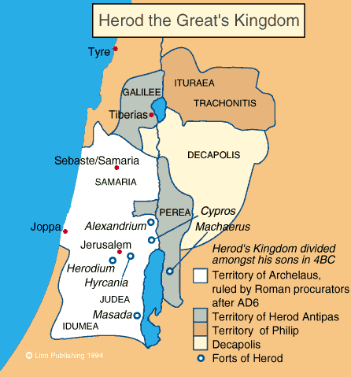
Mark 6:14-16 (ESV)
14 King Herod heard of it, for Jesus' name had become known. Some said, “John the Baptist has been raised from the dead. That is why these miraculous powers are at work in him.” 15 But others said, “He is Elijah.” And others said, “He is a prophet, like one of the prophets of old.” 16 But when Herod heard of it, he said, “John, whom I beheaded, has been raised.”
GREATNESS IN GOD’S EYES
Matthew 11:11 (ESV)
”I tell you, among those born of women none is greater than John”
- Not John-Mark the Evangelist
- Not John the Apostle
- John the BAPTIZER/BAPTIST
Luke 1:13-17 (ESV)
But the angel said to him, “Do not be afraid, Zechariah, for your prayer has been heard, and your wife Elizabeth will bear you a son, and you shall call his name John. 14 And you will have joy and gladness, and many will rejoice at his birth, 15 for he will be great before the Lord. And he must not drink wine or strong drink, and he will be filled with the Holy Spirit, even from his mother's womb. 16 And he will turn many of the children of Israel to the Lord their God, 17 and he will go before Him in the spirit and power of Elijah, to turn the hearts of the fathers to the children, and the disobedient to the wisdom of the just, to make ready for the Lord a people prepared.”
WHAT MADE JOHN GREAT?
John 3:27-30 (ESV)
27 John answered, “A person cannot receive even one thing unless it is given him from heaven. 28 You yourselves bear me witness, that I said, ‘I am not the Christ, but I have been sent before Him.’ 29 The one who has the bride is the Bridegroom. The friend of the Bridegroom, who stands and hears Him, rejoices greatly at the Bridegroom's voice. Therefore this joy of mine is now complete. 30 He must increase, but I must decrease.”
____________________________________________________________________________________________________________________________________________________________________________________________________________________________________________________________________________________________________________
Luke 7:24-28 (ESV)
24 When John's messengers had gone, Jesus began to speak to the crowds concerning John: “What did you go out into the wilderness to see? A reed shaken by the wind? 25 What then did you go out to see? A man dressed in soft clothing? Behold, those who are dressed in splendid clothing and live in luxury are in kings' courts. 26 What then did you go out to see? A prophet? Yes, I tell you, and more than a prophet. 27 This is he of whom it is written,
“‘Behold, I send my messenger before your face, who will prepare your way before you.’
28 I tell you, among those born of women none is greater than John. Yet the one who is least in the kingdom of God is greater than he.”
HOW CAN WE LIVE LIVES OF GREATNESS?
BIG, BOLD, PASSIONATE & FULL OF HUMILITY
____________________________________________________________________________________________________________________________________________________________________________________
THE GRAVITY OF SIN
Mark 6:17-29 (ESV)
17 For it was Herod who had sent and seized John and bound him in prison for the sake of Herodias, his brother Philip's wife, because he had married her. 18 For John had been saying to Herod, “It is not lawful for you to have your brother's wife.” 19 And Herodias had a grudge against him and wanted to put him to death. But she could not, 20 for Herod feared John, knowing that he was a righteous and holy man, and he kept him safe. When he heard him, he was greatly perplexed, and yet he heard him gladly.
21 But an opportunity came when Herod on his birthday gave a banquet for his nobles and military commanders and the leading men of Galilee. 22 For when Herodias's daughter came in and danced, she pleased Herod and his guests. And the king said to the girl, “Ask me for whatever you wish, and I will give it to you.” 23 And he vowed to her, “Whatever you ask me, I will give you, up to half of my kingdom.” 24 And she went out and said to her mother, “For what should I ask?” And she said, “The head of John the Baptist.” 25 And she came in immediately with haste to the king and asked, saying, “I want you to give me at once the head of John the Baptist on a platter.” 26 And the king was exceedingly sorry, but because of his oaths and his guests he did not want to break his word to her. 27 And immediately the king sent an executioner with orders to bring John's head. He went and beheaded him in the prison 28 and brought his head on a platter and gave it to the girl, and the girl gave it to her mother. 29 When his disciples heard of it, they came and took his body and laid it in a tomb.
THE GRACE OF GOD
John 3:16-17 (ESV)
16 “For God so loved the world, that he gave his only Son, that whoever believes in him should not perish but have eternal life. 17 For God did not send his Son into the world to condemn the world, but in order that the world might be saved through him.

