THE HEART OF HEALING
Mark 7:31-37 (ESV)
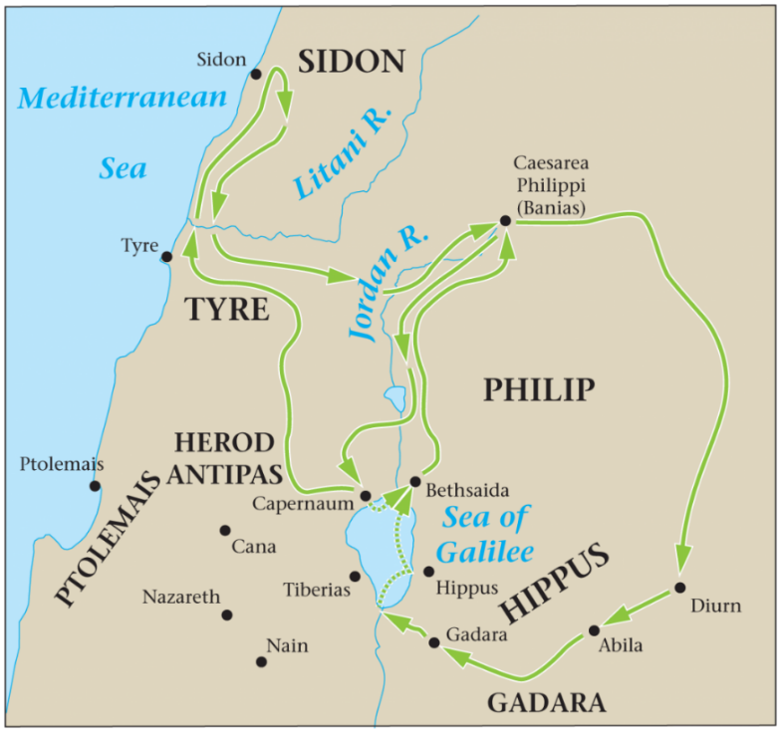
MARK 7:31-37 (ESV) – Jesus Heals a Deaf Man
31 Then he returned from the region of Tyre and went through Sidon to the Sea of Galilee, in the region of the Decapolis. 32 And they brought to him a man who was deaf and had a speech impediment, and they begged him to lay his hand on him. 33 And taking him aside from the crowd privately, he put his fingers into his ears, and after spitting touched his tongue. 34 And looking up to heaven, he sighed and said to him, “Ephphatha,” that is, “Be opened.” 35 And his ears were opened, his tongue was released, and he spoke plainly. 36 And Jesus charged them to tell no one. But the more he charged them, the more zealously they proclaimed it. 37 And they were astonished beyond measure, saying, “He has done all things well. He even makes the deaf hear and the mute speak.”
FOUR REASONS THAT JESUS HEALED:
- JESUS HEALED TO DEMONSTRATE HIS DIVINITY
See the seven Miracles and seven “I AM” statements in the Gospel of John
______________________________________________________________________________________________________________________________________
- JESUS HEALED TO REVEAL THE NATURE OF THE KINGDOM OF GOD
Matthew 4:23 (ESV) And he went throughout all Galilee, teaching in their synagogues and proclaiming the gospel of the kingdom and healing every disease and every affliction among the people.
______________________________________________________________________________________________________________________________________
- JESUS HEALED AS AN EXAMPLE FOR HIS DISCIPLES TO FOLLOW
Luke 9:1-2, 6 (ESV) And he called the twelve together and gave them power and authority over all demons and to cure diseases, 2 and he sent them out to proclaim the kingdom of God and to heal. 6 And they departed and went through the villages, preaching the gospel and healing everywhere.
______________________________________________________________________________________________________________________________________
- JESUS HEALED BECAUSE HE WAS MOVED WITH COMPASSION
Matthew 9:35-38 (ESV) Jesus traveled through all the towns and villages of that area, teaching in the synagogues, and announcing the Good News about the Kingdom. And he healed every kind of disease and illness. 36 When he saw the crowds, he had compassion on them because they were confused and helpless, like sheep without a shepherd. 37 He said to his disciples, ‘The harvest is great, but the workers are few. 38 So pray to the Lord who is in charge of the harvest; ask him to send more workers into his fields.’
____________________________________________________________________________________________________________________________________________________________________________________________________________________________________________________________________________
THREE PRINCIPLES FOR PRAYING FOR HEALING LIKE JESUS:
- JESUS CARED ABOUT PEOPLE, NOT PERFORMING
33 And taking him aside from the crowd privately…
____________________________________________________________________________________________________________________________________________________________________________________________________________________________________________________________________________
- JESUS CARED ABOUT TENDERNESS, NOT TECHNIQUE
…he put his fingers into his ears, and after spitting touched his tongue…
____________________________________________________________________________________________________________________________________________________________________________________________________________________________________________________________________________
- JESUS DIRECTED PEOPLE TO THE HEALER, NOT THE HEALING
34 And looking up to heaven, he sighed and said to him, “Ephphatha,” that is, “Be opened.” 35 And his ears were opened, his tongue was released, and he spoke plainly.
____________________________________________________________________________________________________________________________________________________________________________________________________________________________________________________________________________

