THE MOST IMPORTANT QUESTION
Mark 8:11-30 (ESV)
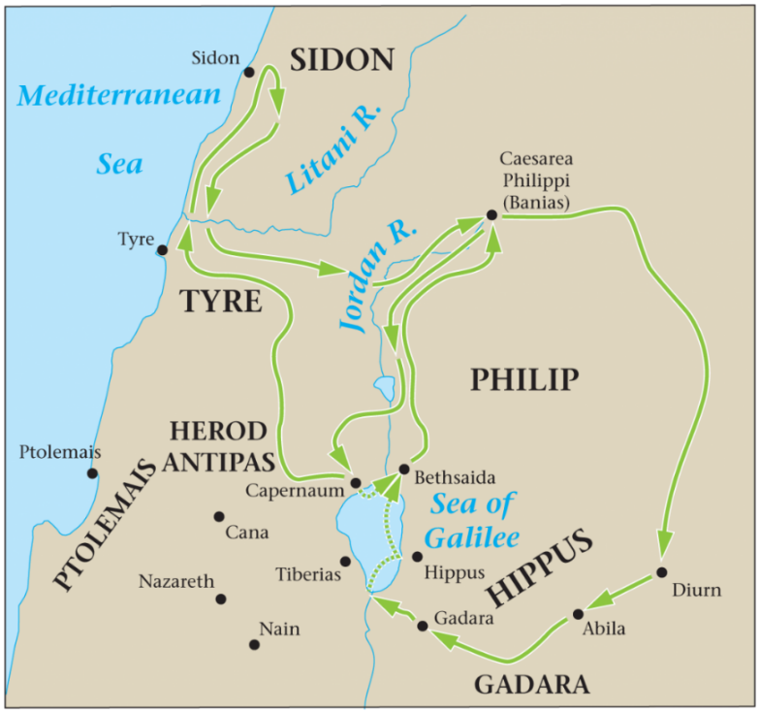
THE SELF-RIGHTEOUS REJECTED
11 The Pharisees came and began to argue with him, seeking from him a sign from heaven to test him. 12 And he sighed deeply in his spirit and said, “Why does this generation seek a sign? Truly, I say to you, no sign will be given to this generation.” 13 And he left them, got into the boat again, and went to the other side.
__________________________________
__________________________________
__________________________________
__________________________________
THE STUDENTS REBUKED
14 Now they had forgotten to bring bread, and they had only one loaf with them in the boat. 15 And he cautioned them, saying, “Watch out; beware of the leaven of the Pharisees and the leaven of Herod.” 16 And they began discussing with one another the fact that they had no bread. 17 And Jesus, aware of this, said to them, “Why are you discussing the fact that you have no bread? Do you not yet perceive or understand? Are your hearts hardened? 18 Having eyes do you not see, and having ears do you not hear? And do you not remember? 19 When I broke the five loaves for the five thousand, how many baskets full of broken pieces did you take up?” They said to him, “Twelve.” 20 “And the seven for the four thousand, how many baskets full of broken pieces did you take up?” And they said to him, “Seven.” 21 And he said to them, “Do you not yet understand?”
______________________________________________________________________________________________________________________________________________________________________________________________________________________________________________________________________________________________________________________________________________________________________________________________________________________________________________________________________________________________________________________________________________________________________________________________________________________________________________________________________________________________
THE SIGHT RESTORED
22 And they came to Bethsaida. And some people brought to him a blind man and begged him to touch him. 23 And he took the blind man by the hand and led him out of the village, and when he had spit on his eyes and laid his hands on him, he asked him, “Do you see anything?” 24 And he looked up and said, “I see people, but they look like trees, walking.” 25 Then Jesus laid his hands on his eyes again; and he opened his eyes, his sight was restored, and he saw everything clearly. 26 And he sent him to his home, saying, “Do not even enter the village.”
________________________________________________________________________________________________________________________________________________________________________________________________________________________________________________________________________________________________________________________________________________________________________________________________________________________________________________________________________________________________________________________________________________________
THE SAVIOR RECOGNIZED
27 And Jesus went on with his disciples to the villages of Caesarea Philippi. And on the way he asked his disciples, “Who do people say that I am?” 28 And they told him, “John the Baptist; and others say, Elijah; and others, one of the prophets.” 29 And he asked them, “But who do you say that I am?” Peter answered him, “You are the Christ.” 30 And he strictly charged them to tell no one about him.
_________________________________________________________________________________________________________________________________________________________________________________________________________________________________________________________________________________________________________________________________________________________________________________________________________________________________________________________________________________________________________________________________________________________________________________________________________________________________________________________________________________________________________________________________________________________________

